**实验10 定位与定位布局**

**一、实验目的：**

1、掌握定位的用法；

2、掌握并能熟练使用定位与定位布局。

**二、实验用的仪器和材料：**

硬件：PC电脑一台；

配置：内存，2G及以上 硬盘250G及以上

软件环境：Adobe Dreamweaver

1. **实验要求：**

**1：参考给出的PSD源文件和定位知识点对页面进行定位布局，页面的PSD源文件已经给出（见PSD源文件）。**

最终效果：

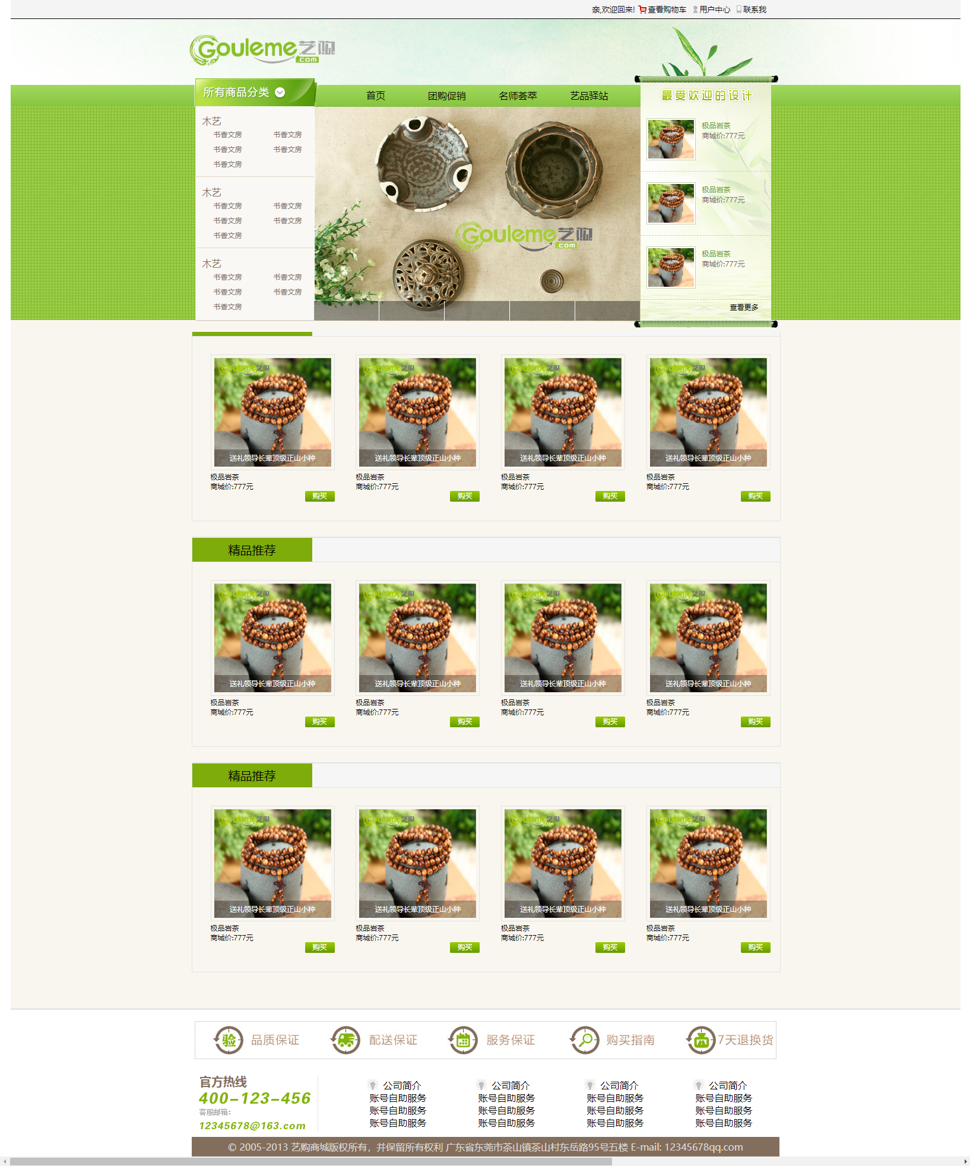

HTML结构：

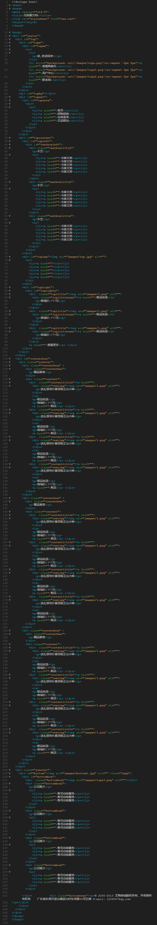

CSS样式：

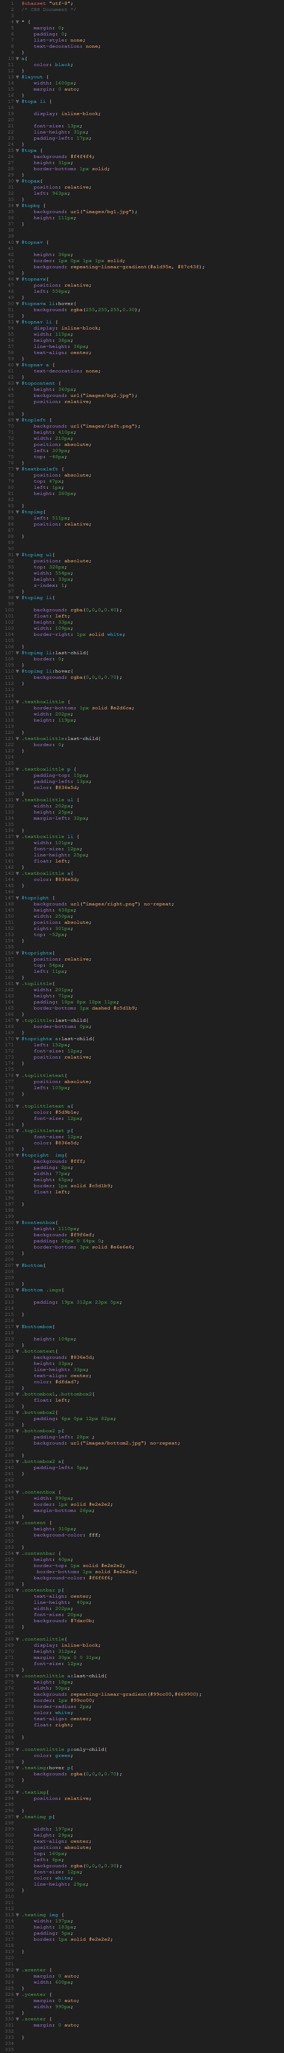

**页面HTML结构截图：**

<!doctype html>

<html>

<head>

<meta charset="utf-8">

<title>无标题文档</title>

<link rel="stylesheet" href="css.css">

<style></style>

</head>

<body>

<div id="layout">

<div id="top">

<div id="topa">

<div id="topax">

<ul>

<li>

<p>亲,欢迎回来!</p>

</li>

<li style="background: url('images/topa.png')no-repeat -3px 5px"><a href="">查看购物车</a></li>

<li style="background: url('images/topa1.png')no-repeat 0px 5px"><a href="">用户中心</a></li>

<li style="background: url('images/topa2.png')no-repeat 0px 5px"><a href="">联系我</a></li>

</ul>

</div>

</div>

<div id="topbg"></div>

<div id="topnav">

<div id="topnavx">

<div>

<ul>

<li><a href="">首页</a></li>

<li><a href="">团购促销</a></li>

<li><a href="">名师荟萃</a></li>

<li><a href="">艺品驿站</a></li>

</ul>

</div>

</div>

</div>

<div id="topcontent">

<div id="topleft">

<div id="textboxleft">

<div class="textboxlittle">

<p>木艺</p>

<ul>

<li><a href="">书香文房</a></li>

<li><a href="">书香文房</a></li>

<li><a href="">书香文房</a></li>

<li><a href="">书香文房</a></li>

<li><a href="">书香文房</a></li>

</ul>

</div>

<div class="textboxlittle">

<p>木艺</p>

<ul>

<li><a href="">书香文房</a></li>

<li><a href="">书香文房</a></li>

<li><a href="">书香文房</a></li>

<li><a href="">书香文房</a></li>

<li><a href="">书香文房</a></li>

</ul>

</div>

<div class="textboxlittle">

<p>木艺</p>

<ul>

<li><a href="">书香文房</a></li>

<li><a href="">书香文房</a></li>

<li><a href="">书香文房</a></li>

<li><a href="">书香文房</a></li>

<li><a href="">书香文房</a></li>

</ul>

</div>

</div>

</div>

<div id="topimg"><img src="images/top.jpg" alt="">

<ul>

<li><a href=""></a></li>

<li><a href=""></a></li>

<li><a href=""></a></li>

<li><a href=""></a></li>

<li><a href=""></a></li>

</ul>

</div>

<div id="topright">

<div id="toprightx">

<div class="toplittle"><img src="images/1.png" alt="">

<div class="toplittletext"><a href="">极品岩茶</a>

<p>商城价:777元</p>

</div>

</div>

<div class="toplittle"><img src="images/1.png" alt="">

<div class="toplittletext"><a href="">极品岩茶</a>

<p>商城价:777元</p>

</div>

</div>

<div class="toplittle"><img src="images/1.png" alt="">

<div class="toplittletext"><a href="">极品岩茶</a>

<p>商城价:777元</p>

</div>

</div>

<a href="">查看更多</a> </div>

</div>

</div>

</div>

<div id="contentbox">

<div class="ycenter">

<div class="contentbox" >

<div class="contentbar">

<p>精品推荐</p>

</div>

<div class="content">

<div class="contentlittle"><a href="">

<div class="textimg"><img src="images/1.png" alt="">

<p>送礼领导长辈顶级正山小种</p>

</div>

</a>

<p>极品岩茶</p>

<p>商城价:777元</p>

<a href="">购买</a> </div>

<div class="contentlittle"><a href="">

<div class="textimg"><img src="images/1.png" alt="">

<p>送礼领导长辈顶级正山小种</p>

</div>

</a>

<p>极品岩茶</p>

<p>商城价:777元</p>

<a href="">购买</a> </div>

<div class="contentlittle"><a href="">

<div class="textimg"><img src="images/1.png" alt="">

<p>送礼领导长辈顶级正山小种</p>

</div>

</a>

<p>极品岩茶</p>

<p>商城价:777元</p>

<a href="">购买</a> </div>

<div class="contentlittle"><a href="">

<div class="textimg"><img src="images/1.png" alt="">

<p>送礼领导长辈顶级正山小种</p>

</div>

</a>

<p>极品岩茶</p>

<p>商城价:777元</p>

<a href="">购买</a> </div>

</div>

</div>

<div class="contentbox" >

<div class="contentbar">

<p>精品推荐</p>

</div>

<div class="content">

<div class="contentlittle"><a href="">

<div class="textimg"><img src="images/1.png" alt="">

<p>送礼领导长辈顶级正山小种</p>

</div>

</a>

<p>极品岩茶</p>

<p>商城价:777元</p>

<a href="">购买</a> </div>

<div class="contentlittle"><a href="">

<div class="textimg"><img src="images/1.png" alt="">

<p>送礼领导长辈顶级正山小种</p>

</div>

</a>

<p>极品岩茶</p>

<p>商城价:777元</p>

<a href="">购买</a> </div>

<div class="contentlittle"><a href="">

<div class="textimg"><img src="images/1.png" alt="">

<p>送礼领导长辈顶级正山小种</p>

</div>

</a>

<p>极品岩茶</p>

<p>商城价:777元</p>

<a href="">购买</a> </div>

<div class="contentlittle"><a href="">

<div class="textimg"><img src="images/1.png" alt="">

<p>送礼领导长辈顶级正山小种</p>

</div>

</a>

<p>极品岩茶</p>

<p>商城价:777元</p>

<a href="">购买</a> </div>

</div>

</div>

<div class="contentbox" >

<div class="contentbar">

<p>精品推荐</p>

</div>

<div class="content">

<div class="contentlittle"><a href="">

<div class="textimg"><img src="images/1.png" alt="">

<p>送礼领导长辈顶级正山小种</p>

</div>

</a>

<p>极品岩茶</p>

<p>商城价:777元</p>

<a href="">购买</a> </div>

<div class="contentlittle"><a href="">

<div class="textimg"><img src="images/1.png" alt="">

<p>送礼领导长辈顶级正山小种</p>

</div>

</a>

<p>极品岩茶</p>

<p>商城价:777元</p>

<a href="">购买</a> </div>

<div class="contentlittle"><a href="">

<div class="textimg"><img src="images/1.png" alt="">

<p>送礼领导长辈顶级正山小种</p>

</div>

</a>

<p>极品岩茶</p>

<p>商城价:777元</p>

<a href="">购买</a> </div>

<div class="contentlittle"><a href="">

<div class="textimg"><img src="images/1.png" alt="">

<p>送礼领导长辈顶级正山小种</p>

</div>

</a>

<p>极品岩茶</p>

<p>商城价:777元</p>

<a href="">购买</a> </div>

</div>

</div>

</div>

</div>

<div class="ycenter">

<div id="bottom"><img src="images/bottom1.jpg" alt="" class="imgs">

<div id="bottombox">

<div class="bottombox1"><img src="images/topa3.png" alt=""></div>

<div class="bottombox2">

<p>公司简介</p>

<ul>

<li><a href="">账号自助服务</a></li>

<li><a href="">账号自助服务</a></li>

<li><a href="">账号自助服务</a></li>

</ul>

</div>

<div class="bottombox2">

<p>公司简介</p>

<ul>

<li><a href="">账号自助服务</a></li>

<li><a href="">账号自助服务</a></li>

<li><a href="">账号自助服务</a></li>

</ul>

</div>

<div class="bottombox2">

<p>公司简介</p>

<ul>

<li><a href="">账号自助服务</a></li>

<li><a href="">账号自助服务</a></li>

<li><a href="">账号自助服务</a></li>

</ul>

</div>

<div class="bottombox2">

<p>公司简介</p>

<ul>

<li><a href="">账号自助服务</a></li>

<li><a href="">账号自助服务</a></li>

<li><a href="">账号自助服务</a></li>

</ul>

</div>

</div> <div class="bottomtext"><p>© 2005-2013 艺购商城版权所有，并保留所有权利 广东省东莞市茶山镇茶山村东岳路95号五楼 E-mail: 12345678qq.com

</p></div>

</div>

</div>

</div>

</body>

</html>

**页面CSS截图：**

@charset "utf-8";

/* CSS Document */

* {

margin: 0;

padding: 0;

list-style: none;

text-decoration: none;

}

a{

color: black;

}

#layout {

width: 1600px;

margin: 0 auto;

}

#topa li {

display: inline-block;

font-size: 13px;

line-height: 31px;

padding-left: 17px;

}

#topa {

background: #f4f4f4;

height: 31px;

border-bottom: 1px solid;

}

#topax{

position: relative;

left: 963px;

}

#topbg {

background: url("images/bg1.jpg");

height: 111px;

}

#topnav {

height: 36px;

border: 1px 0px 1px 1px solid;

background: repeating-linear-gradient(#a1d95e, #87c43f);

}

#topnavx{

position: relative;

left: 558px;

}

#topnavx li:hover{

background: rgba(255,255,255,0.30);

}

#topnav li {

display: inline-block;

width: 115px;

height: 38px;

line-height: 36px;

text-align: center;

}

#topnav a {

text-decoration: none;

}

#topcontent {

height: 360px;

background: url("images/bg2.jpg");

position: relative;

}

#topleft {

background: url("images/left.png");

height: 410px;

width: 210px;

position: absolute;

left: 309px;

top: -48px;

}

#textboxleft {

position: absolute;

top: 47px;

left: 1px;

height: 360px;

}

#topimg{

left: 511px;

position: relative;

}

#topimg ul{

position: absolute;

top: 328px;

width: 554px;

height: 33px;

z-index: 1;

}

#topimg li{

background: rgba(0,0,0,0.40);

float: left;

height: 33px;

width: 109px;

border-right: 1px solid white;

}

#topimg li:last-child{

border: 0;

}

#topimg li:hover{

background: rgba(0,0,0,0.70);

}

.textboxlittle {

border-bottom: 1px solid #e2d6ca;

width: 202px;

height: 119px;

}

.textboxlittle:last-child{

border: 0;

}

.textboxlittle p {

padding-top: 15px;

padding-left: 13px;

color: #836e5d;

}

.textboxlittle ul {

width: 202px;

height: 25px;

margin-left: 32px;

}

.textboxlittle li {

width: 101px;

font-size: 12px;

line-height: 25px;

float: left;

}

.textboxlittle a{

color: #836e5d;

}

#topright {

background: url("images/right.png") no-repeat;

height: 438px;

width: 250px;

position: absolute;

right: 301px;

top: -52px;

}

#toprightx{

position: relative;

top: 54px;

left: 11px;

}

.toplittle{

width: 201px;

height: 71px;

padding: 18px 8px 18px 11px;

border-bottom: 1px dashed #c5d1b9;

}

.toplittle:last-child{

border-bottom: 0px;

}

#toprightx a:last-child{

left: 152px;

font-size: 12px;

position: relative;

}

.toplittletext{

position: absolute;

left: 105px;

}

.toplittletext a{

color: #5d9b1e;

font-size: 12px;

}

.toplittletext p{

font-size: 12px;

color: #836e5d;

}

#topright img{

background: #fff;

padding: 2px;

width: 77px;

height: 65px;

border: 1px solid #c5d1b9;

float: left;

}

#contentbox{

height: 1110px;

background: #f9f6ef;

padding: 26px 0 64px 0;

border-bottom: 3px solid #e6e6e6;

}

#bottom{

}

#bottom .imgs{

padding: 19px 312px 23px 5px;

}

#bottombox{

height: 104px;

}

.bottomtext{

background: #836e5d;

height: 33px;

line-height: 33px;

text-align: center;

color: #dfdad7;

}

.bottombox1,.bottombox2{

float: left;

}

.bottombox2{

padding: 6px 0px 12px 82px;

}

.bottombox2 p{

padding-left: 28px ;

background: url("images/bottom2.jpg") no-repeat;

}

.bottombox2 a{

padding-left: 5px;

}

.contentbox {

width: 990px;

border: 1px solid #e2e2e2;

margin-bottom: 26px;

}

.content {

height: 310px;

background-color: fff;

}

.contentbar {

height: 40px;

border-top: 1px solid #e2e2e2;

border-bottom: 1px solid #e2e2e2;

background-color: #f6f6f6;

}

.contentbar p{

text-align: center;

line-height: 40px;

width: 202px;

font-size: 20px;

background: #7dac0b;

}

.contentlittle{

display: inline-block;

height: 312px;

margin: 30px 0 0 31px;

font-size: 12px;

}

.contentlittle a:last-child{

height: 18px;

width: 50px;

background: repeating-linear-gradient(#99cc00,#669900);

border: 1px #99cc00;

border-radius: 2px;

color: white;

text-align: center;

float: right;

}

.contentlittle p:only-child{

color: green;

}

.textimg:hover p{

background: rgba(0,0,0,0.70);

}

.textimg{

position: relative;

}

.textimg p{

width: 197px;

height: 29px;

text-align: center;

position: absolute;

top: 160px;

left: 6px;

background: rgba(0,0,0,0.30);

font-size: 12px;

color: white;

line-height: 29px;

}

.textimg img {

width: 197px;

height: 183px;

padding: 5px;

border: 1px solid #e2e2e2;

}

.xcenter {

margin: 0 auto;

width: 600px;

}

.ycenter {

margin: 0 auto;

width: 990px;

}

.zcenter {

margin: 0 auto;

}